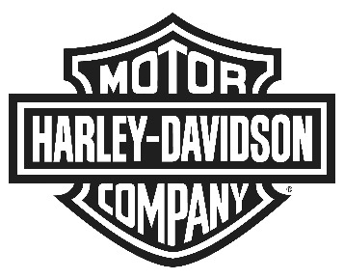
Harley-Davidson Europe Ltd
Oxford Business Park, 6000 Garsington Road, Oxford, OX4 2DQ
United Kingdom NEWS

ONE INCREDIBLE TOUR, ONE INCREDIBLE RIDER; HARLEY-DAVIDSON® DISCOVER MORE 2015 TOUR BEGINS

Luis Castilla sets off on road trip across the best touring roads in Europe

LONDON, UK (May. 26, 2015) – Harley-Davidson today begins its Discover More 2015 campaign, the ultimate motorcycling touring adventure which will see passionate motorcyclist Luis Castilla embark on the journey of his life. He will experience some of the most spectacular and breathtaking motorcycling roads Europe has to offer, travelling across the continent throughout the summer.

Castilla was chosen from more than 10,000 applicants from 27 different countries for the Discover More initiative and experience a two-month, all-expenses-paid European journey of discovery on a Harley-Davidson® Street Glide® Special motorcycle. He has also been paid €25,000 for the adventure and will get to keep the motorcycle when the tour comes to an end.

Castilla starts his adventure this week in London and will continue his journey riding through some of the most renowned touring roads in Europe, discovering vibrant cultures, sights and sounds along the way. The route will include a visit to the Norwegian Fjords, French Riviera and Cat and Fiddle road in the UK, all of which will showcase the spirit of discovery that comes with touring on a Harley-Davidson motorcycle.

“Ever since being selected as the winner for the Harley-Davidson Discover More campaign, I have not been able to contain my excitement as I know this will be the most amazing experience of my life. I have been overwhelmed with messages of congratulations from fellow touring enthusiasts across the world. Many have shared some beautiful and incredible European road trips that have inspired the stunning route on which I will be setting off today. I am looking forward to sharing my experience over the next two months that will hopefully encourage others to undertake a similar adventure themselves” said Castilla.

Castilla is being accompanied by a professional film crew which will capture every moment of emotion, adventure and discovery experienced on each twist and turn of his journey through Europe. His experience will be shared on social media and through a dedicated blog on the ‘Greatest Rides’ website www.greatestrides.eu.

The website also gives riders across Europe, the Middle East and Africa the chance to upload and share highlights from their own great rides with fellow touring enthusiasts. The online community created by riders for riders will allow people to research and discover interesting roads, places and events local to them when out on the road, regardless of the brand or style of motorcycle they ride.

For more information on the Discover More Tour and to follow Castilla on his journey, visit www.greatestrides.eu or use #discovermore2015.

About Harley-Davidson Motor Company
Harley-Davidson Motor Company® produces custom, cruiser and touring motorcycles and offers a complete line of Harley-Davidson motorcycle parts, accessories, riding gear and apparel, and general merchandise. For more information, visit Harley-Davidson's website at www.h-d.com.

# # #

